English 2381: Introduction to the Black Atlantic

Rationale: At least since Paul Gilroy’s seminal book The Black Atlantic (1993), scholars have been invested in a diaspora of black literature and media that moves beyond traditional disciplinary borders and across literary subfields. Covering transatlantic literature, visual culture, and primary documentation such as the first Haitian constitution and the pamphlets of Jamaican revolt, “English 2381: The Black Atlantic” would involve students in the culture of black struggle--for freedom, equal recognition, and civic representation. As we have designed it, the course is also comparative. For example, to show the persistent modern aspiration of black nationhood, we place texts from Haiti’s revolution side by side with the 2018 superhero film Black Panther.

There are three primary reasons to add such a course to the English curriculum. First, the course is highly relevant to the present struggle for racial justice. We in the United States are living through a second civil rights movement--but its liberatory current has also swept across the globe. Broadcast around the world via traditional and social media, these uprisings recall the dissemination of influential abolitionist texts and images internationally throughout the 18th-19th centuries. Second, the course may include a broader media component, as it brings together text and image, both still and moving. GE students who may be less comfortable with older literatures and styles of composition may be encouraged by the course’s pivoting between, say, The History of Mary Prince (1832) and Ousmane Sembène’s 1966 film Black Girl. Not only could such an arrangement compliment and prepare students for an array of existing courses in black literature, but it could presage many of the courses in media, film, and television for which OSU’s faculty is also known. Finally, the course could involve a whole range of faculty across national traditions (the U.S., Britain, Africa, the Caribbean) and centuries (from the 17th to the 21st). In fact, the original offering was designed to be team-taught, perhaps by one faculty member working in American lit and the other working in the British/European area (although the budget structure of the university may, sadly, prohibit such an arrangement.) This setup underscores the transatlanticism of the Black Atlantic itself and could produce a new, perhaps exciting, dynamic for students and instructors. We have enclosed a syllabus constructed by Jamison Kantor and Elizabeth Hewitt, but other colleagues including Susan Williams, Jacob Risinger, Clare Simmons, and Jesse Schotter have indicated their interest in teaching the course.

We should also note that the course would fulfill a requirement Race, Ethnicity and Gender Diversity. Surprisingly, very few of our GE offerings in the English Department address this requirement.

English 2381: Introduction to the Black Atlantic

Prof. Elizabeth Hewitt (hewitt.33@osu.edu) and Jamison Kantor (kantor.41@osu.edu)
Tuesdays and Thursdays, 11:10 am-12:30 pm. in xxxxx

Description: The term ‘Black Atlantic’ comes from the title of a book by cultural historian, Paul Gilroy, to describe the encounters between African, European, and American that he argues have shaped our modern world: its politics, its literature, its art, and its economics. This class will study the literature of this encounter--as well as relevant media in visual art and cinema--focusing on work that describes the enslavement of Africans and literature that depicts resistance to slavery, racism, and the politics of white supremacy. We will also consider the ways that the black writers and artists across 4 centuries have represented the African diaspora and its effects on the conception of black citizenship.

Expected Learning Outcomes:
- To analyze writing about slavery (the Atlantic slave trade and the enslavement of African peoples) and the significance of slavery to definitions of citizenship in the United States and Great Britain.
- To analyze writing about the African diaspora and the ways its provides a unique model for the study of global citizenship.
- To analyze historical texts across a variety of genres (fiction, poetry, autobiography), media (text, film, still image) and disciplines (literature, politics, economics) and gain aptitude in such comparative work.
- To study the literature of revolution and reform and discover the importance of language in both describing and enacting social change.

General Education Expected Learning Outcomes:

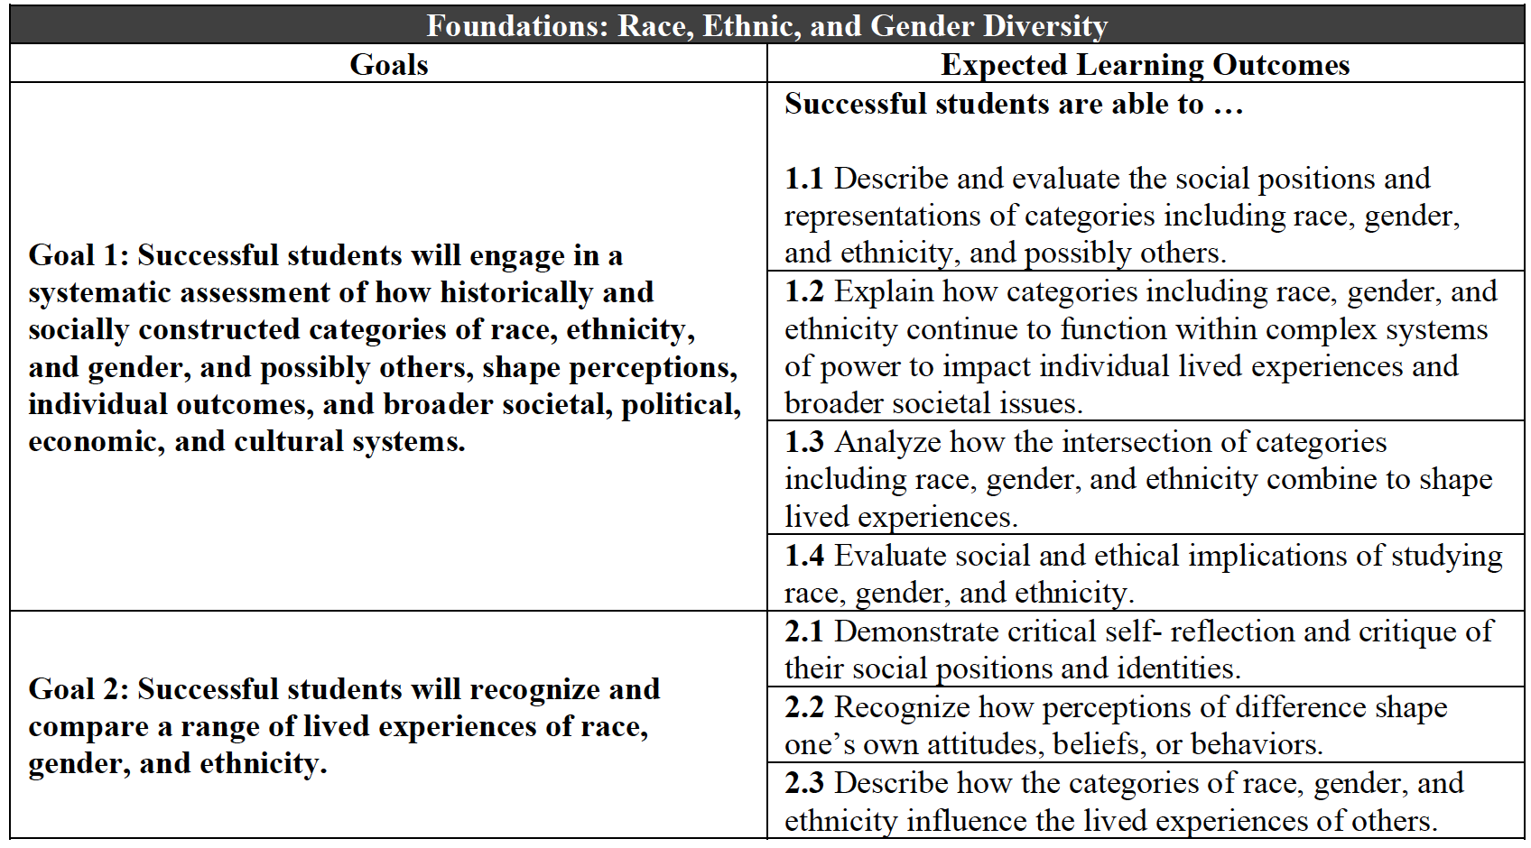

Required Assignments:
Assignments will consist of two response papers (15% each), a midterm (25%), and a comparative media presentation (25%), where students will discover the influences of primary sources on contemporary visual art, film, and literature. Class participation is worth 20% of the overall grade.

Texts:

- Unchained Voices: An Anthology of Black Authors in the English-Speaking World, ed. Vincent Carreta (978-0813190761). UV in syllabus
- Honoré Fanonne Jeffers, The Age of Phillis (978-0819579492)
- The History of Mary Prince (978-1719492324)
- Frederick Douglass, The Heroic Slave, Ed. Robert Levine, John Stauffer, and John R. McKivigan (978-0300184624)
- Herman Melville, Benito Cereno (978-0486264738)
- James McBride, The Good Lord Bird (978-1594632785)
- Course .pdfs – Includes public domain texts from Juan Manzano, John Stedman, Robert Wedderburn, and texts/images on Haitian liberation. * in syllabus

Course Schedule:

Citizen of the World
Tue., 1/11: Intro / Course Policies and Expectations
Th., 1/13: Selections from Narrative of the Most Remarkable Particulars in the Life of James Albert Ukawsaw Gronniosaw (UV pp. 32-58) and Narrative of the Life and Adventures of Venture Smith (UV pp. 369-78)

Tue., 1/18: Olaudah Equiano, from The Interesting Narrative of the Life of Olaudah Equiano (UV pp. 186-215)
Th., 1/20: Olaudah Equiano, from The Interesting Narrative of the Life of Olaudah Equiano (UV pp. 216-244)

Middle Passage
Tue., 1/25: Phillis Wheatley, Selected Poetry (UV pp. 59-71)
Th., 1/27: Phillis Wheatley, Selected Poetry (continued); Honorée Fanonne Jeffers, The Age of Phillis (pp. 1-17)

Tue., 2/1: Honorée Fanonne Jeffers, The Age of Phillis (pp. 23-37; 46; 75-84; 1-3-104); David Dabydeen, from Turner*; J.M.W. Turner “The Slave Ship“ (image)*
Th., 2/3: M. NourbeSe Philip, from Zong!*

Migratory Labor
Tue., 2/8: Mary Prince, The History of Mary Prince (pp. 1-38)
Th., 2/10: Mary Prince, The History of Mary Prince (continued)

Tue., 2/15: Black Girl (dir: Ousmane Sembène, 1966)
Th., 2/17: Black Girl

Tue., 2/22: Juan Manzano, from Poems by a Slave in the Island of Cuba, Recently Liberated *
Th., 2/24: Frances Harper, selected poems*; Paul Laurence Dunbar, selected poems*

Black Nation
Tue., 3/1: Primary documents and reflections on the Haitian Revolution: “Decree of the
National Convention” and “Constitution”*
Th., 3/3: C.L.R James, “From Touissant L’Ouverture to Fidel Castro”*; William Wordsworth, “To Toussaint L’Ouverture”;* Paintings from Guillaume Lethière*.

Tue., 3/8: Black Panther (dir. Ryan Coogler, 2018)
Th., 3/10: Black Panther

-SPRING BREAK-

Black Revolution
Tue., 3/22: John Stedman, from The Narrative of a Five Years Expedition against the Revolted Negroes of Surinam*
Th., 3/24: Robert Wedderburn, writings on Jamaican liberation*

Tue., 3/29: Frederick Douglass, “The Heroic Slave” (pp. 3-52)
Th., 3/31: Frederick Douglass, “The Heroic Slave” (continued)

Tue., 4/5: Herman Melville, Benito Cereno (pp. 38-92)
Th., 4/7: Herman Melville, Benito Cereno (pp. 93-112)

Tue., 4/12: James McBride, The Good Lord Bird (pp.1-218)
Th., 4/14: James McBride, The Good Lord Bird (pp. 219-250)

Tue., 4/19: James McBride, The Good Lord Bird (pp. 250-457)
Th., 4/21: Course Wrap-up and Q&A
Important Information:

Ohio State’s academic integrity policy
Academic integrity is essential to maintaining an environment that fosters excellence in teaching, research, and other educational and scholarly activities. Thus, The Ohio State University and the Committee on Academic Misconduct (COAM) expect that all students have read and understand the university’s Code of Student Conduct, and that all students will complete all academic and scholarly assignments with fairness and honesty. Students must recognize that failure to follow the rules and guidelines established in the university’s Code of Student Conduct and this syllabus may constitute “Academic Misconduct.”

The Ohio State University’s Code of Student Conduct (Section 3335-23-04) defines academic misconduct as: “Any activity that tends to compromise the academic integrity of the university or subvert the educational process.” Examples of academic misconduct include (but are not limited to) plagiarism, collusion (unauthorized collaboration), copying the work of another student, and possession of unauthorized materials during an examination. Ignorance of the university’s Code of Student Conduct is never considered an excuse for academic misconduct, so we recommend that you review the Code of Student Conduct and, specifically, the sections dealing with academic misconduct.

t is the responsibility of the Committee on Academic Misconduct to investigate or establish procedures for the investigation of all reported cases of student academic misconduct. The term “academic misconduct” includes all forms of student academic misconduct wherever committed; illustrated by, but not limited to, cases of plagiarism and dishonest practices in connection with examinations. Instructors shall report all instances of alleged academic misconduct to the committee (Faculty Rule 3335-5-487). For additional information, see the Code of Student Conduct http://studentlife.osu.edu/csc/.

If we suspect that a student has committed academic misconduct in this course, we am obligated by university rules to report my suspicions to the Committee on Academic Misconduct. If COAM determines that you have violated the university’s Code of Student Conduct (i.e., committed academic misconduct), the sanctions for the misconduct could include a failing grade in this course and suspension or dismissal from the university.
If you have any questions about the above policy or what constitutes academic misconduct in this course, please contact me.
Other sources of information on academic misconduct (integrity) to which you can refer include:

- The Committee on Academic Misconduct web pages (COAM Home)
- Ten Suggestions for Preserving Academic Integrity (Ten Suggestions)
- Eight Cardinal Rules of Academic Integrity (www.northwestern.edu/uacc/8cards.htm)

Statement on Title IX
All students and employees at Ohio State have the right to work and learn in an environment free from harassment and discrimination based on sex or gender, and the university can arrange interim measures, provide support resources, and explain investigation options, including referral to confidential resources.

If you or someone you know has been harassed or discriminated against based on your sex or gender, including sexual harassment, sexual assault, relationship violence, stalking, or sexual exploitation, you may find information about your rights and options at titleix.osu.edu or by contacting the Ohio State Title IX Coordinator at titleix@osu.edu. Title IX is part of the Office of Institutional Equity (OIE) at Ohio State, which responds to all bias-motivated incidents of harassment and discrimination, such as race, religion, national origin and disability. For more information on OIE, visit equity.osu.edu or email equity@osu.edu.

Your mental health
As a student you may experience a range of issues that can cause barriers to learning, such as strained relationships, increased anxiety, alcohol/drug problems, feeling down, difficulty concentrating and/or lack of motivation. These mental health concerns or stressful events may lead to diminished academic performance or reduce a student's ability to participate in daily activities. The Ohio State University offers services to assist you with addressing these and other concerns you may be experiencing. If you find yourself feeling isolated, anxious or overwhelmed, please know that there are resources to help: ccs.osu.edu. You can reach an on-call counselor when CCS is closed at (614) 292-5766 and 24 hour emergency help is also available through the 24/7 National Prevention Hotline at 1-(800)-273-TALK or at suicidepreventionlifeline.org. The Ohio State Wellness app is also a great resource available at go.osu.edu/wellnessapp.

Academic Support Services and Resources
For support on matters relating to scheduling courses, paying for tuition, and viewing grades at the Student Services Center (http://ssc.osu.edu).
OSU’s Academic Advising website (http://advising.osu.edu/welcome.shtml) will help you schedule an appointment with an advisor, obtain tutoring, order a transcript, or run a degree audit.
Students seeking advice on their English major or minor should visit the Advising page of the English Department website (https://english.osu.edu/undergraduate/advising)

Accessibility accommodations for students with disabilities

Requesting accommodations
The university strives to make all learning experiences as accessible as possible. If you anticipate or experience academic barriers based on your disability including mental health, chronic or temporary medical conditions, please let me know immediately so that we can privately discuss options. To establish reasonable accommodations, we may request that you register with Student Life Disability Services. After registration, make arrangements with me as soon as possible to discuss your accommodations so that they may be implemented in a timely fashion. SLDS contact information: slds@osu.edu; 614-292-3307.

